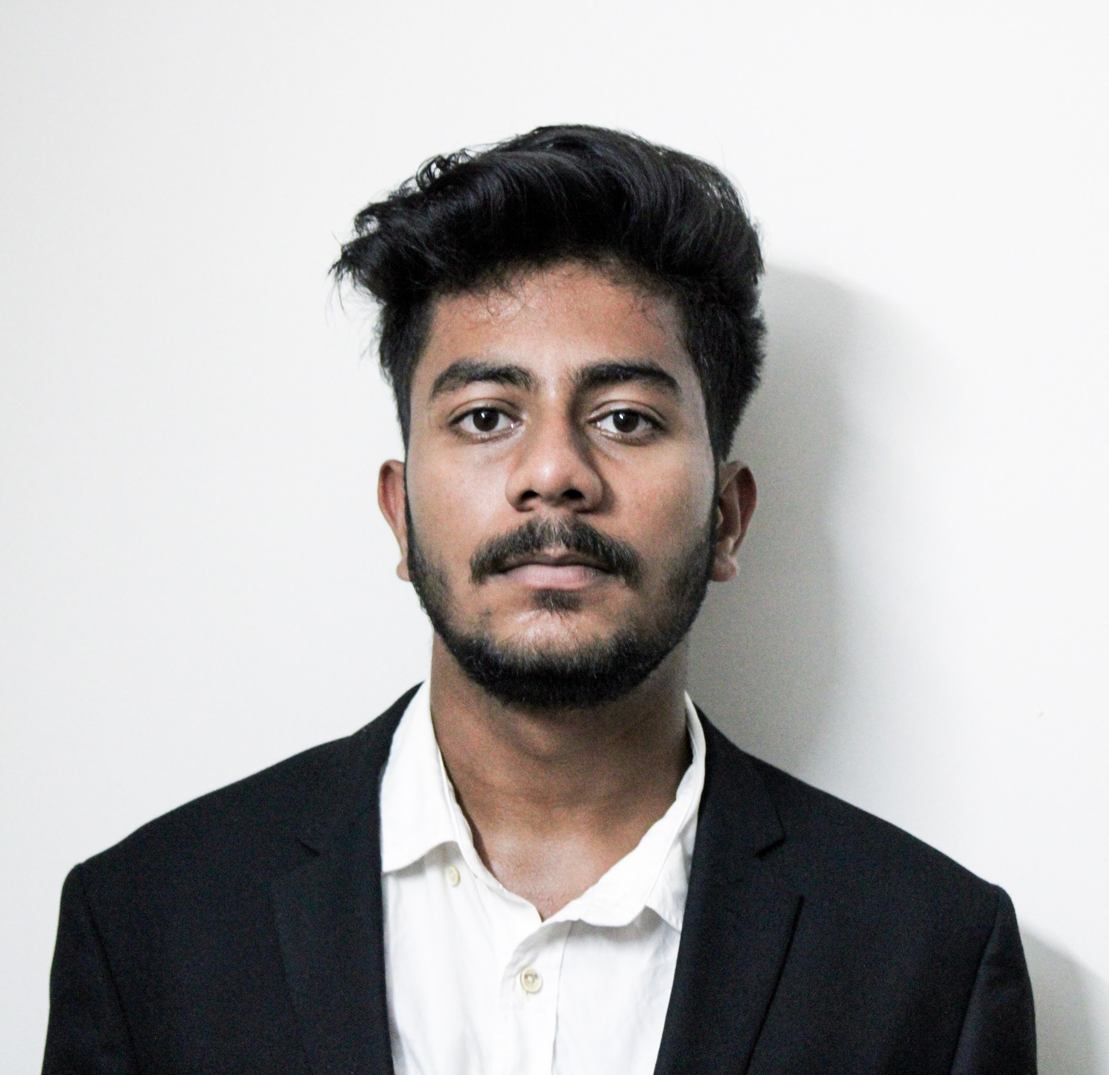

Noel Mathew Thomas | [noelmathew8539@gmail.com](mailto:noelmathew8539@gmail.com)

[noel.thomas@science.christuniversity.in](mailto:noel.thomas@science.christuniversity.in) | +91 6205144760 | <https://www.linkedin.com/in/noel-mathew-thomas-0bbab41b8/>

I am a student of Bachelors of Science(Economics and Analytics) in secondary education, keen on starting an internship with your company which will improve my learning curve and enhance the mentorship culture.

**EDUCATIONAL INFORMATION:**

| **S.No** | **Class / Course** | **School / College / University** | **Percentage** |
| --- | --- | --- | --- |
| **1.** | **B.Sc. Economics and Analytics (Pursuing 4th Semester)** | **Christ (Deemed to be) University, Lavasa, Pune** | **80%** |
| **2.** | **Class 12** | **Dayawati Modi Public School, Jamshedpur** | **78%** |
| **3.** | **Class 10** | **Dayawati Modi Public School, Jamshedpur** | **79%** |

**SEMINAR AND WORKSHOPS ATTENDED-**

* **Economics Conclave on “Contours of Economic Recovery in Post- Covid World” at Christ University Lavasa, Pune.**
* **Regression Analysis at Christ University Lavasa, Pune.**
* **Webinar on “Kick start your Career in Data Science at Christ University Lavasa, Pune.**

**INTERNSHIPS & EXPERIENCE-**

* **Bank of India (2020)**
* Interned as an analyst and economist at the Patna branch of the Bank
* Wrote a research paper on "The impact of the pandemic on the products and services of the bank"

**COURSES COMPLETED -**

* **Introduction to Data Science**
* **Neural Networks and Deep Learning**
* **Excel Crash Course**

****

**KEY SKILLS**

1. **R Programming**
2. **Python Programming**
3. **Microsoft Office**
4. **Photoshop**
5. **Research Methodology**
6. **MySQL**
7. **E-Views**

**ACTIVITIES AND INTERESTS**

1. **Basketball (District level)**
2. **Writing**
3. **Movies**

**PERSONAL DATA**

**Date of Birth**: 08/08/2002

**Gender:** Male

**Nationality**: Indian

**Marital Status**: Unmarried

**Languages Known:** Hindi, English, Malayalam

I hereby declare that the above furnished details are correct to the best of my knowledge.